2012011658 김진권

Ftrace

1. Sched_wakeup

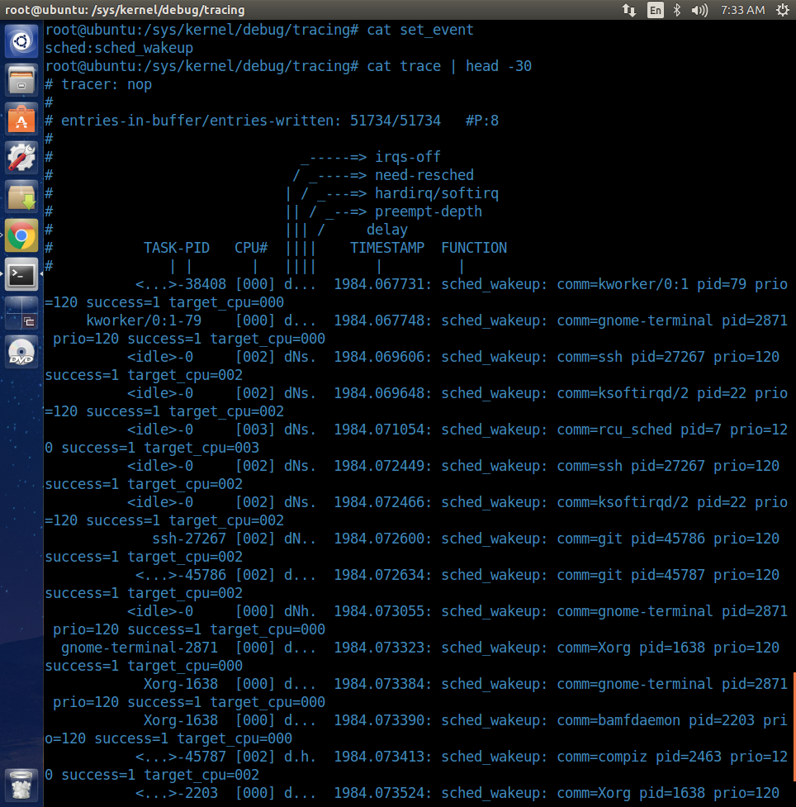

echo 1 > events/sched/sched_wakeup/enable

cat set_event

cat trace | head -20

1. Irqsoff

echo irqsoff > current_tracer

echo 0 > tracing_max_latency

echo 1 > tracing_enabled

cat latency_trace

